

*NAME: AYUSH ..JHATU*

*ROLL NO: 2317024*

*DIV: FYDS*

*SUBJECT: INDIAN KNOWLEDGE SYSTEM*

INDEX

|  |  |  |
| --- | --- | --- |
| SR.NO | TOPICS | PG.NO |
| 1 | INTRODUCTION TO IKS | 3 |
| 2 | BREIF EXPLANATION |  |
| 3 | DETAILED ITINEARY |  |
| 4 | INFORMATION OF PLACES MENTIONED |  |
| 5 | CONCLUSION |  |
| 6 | REFERENCES |  |

* INTRODUCTION OF INDIAN KNOWLEDGE SYSTEM

WHAT IS INDIAN KNOWLEDGE SYSTEM?

INDIAN KNOWLEDGE SYSTEM(IKS) is an innovative cell under the Ministry of Education (MOE) at AICTE, New Delhi. It is established to promote interdisciplinary research on all aspects of IKS, preserve and disseminate IKS for further research and societal applications.IT will actively engage for spreading the rich heritage of our country and traditional knowledge in the field of Arts and Literature, Agriculture, Basic Science, Engineering& Technology, Architecture, Management, Economics, etc.

ABOUT INDIAN KNOWLEDGE SYSTEM

The Indian traditional Knowledge Systems (Bhartiya Ganana Parampara) division of ministry of education (MoE) located at the headquarter of AICET, Delhi, was established as of October 20 and taken to be a part of the New Education Policy (NEP) starting 2023. e team initially consisted of Shri A.B. Shukla was the Chief Coordinator, followed by the teachers Dr. Sanjeev Panchal, Shri Anurag Deshpande and Shri Shreyas Khurekar. more professors who joined this noble research.

WHY ARE WE STUDYING IKS?

The main objective of drawing from our past and integrating the Indian Knowledge Systems is to learn that our ancient systems of knowledge represented by an unbroken tradition of knowledge mission and providing a unique perspective (Bhartiya Drishti) is used to solve the current merging challenges of India and the world.

* BREIF EXPLANATION
* DETAILED ITINEARY
* INFORMATION OF THE PLACES MENTIONED
* Calangute Beach

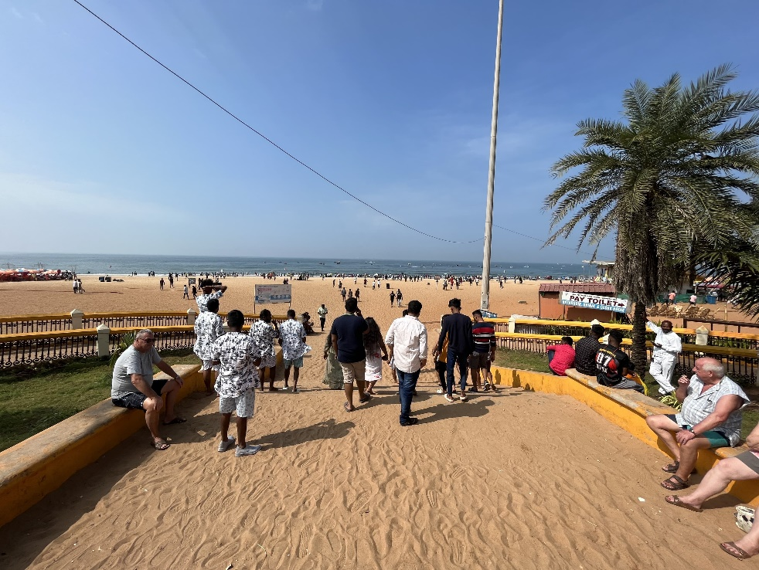

Calangute Beach, located in North Goa, is one of the most popular and bustling beaches in the region, drawing both domestic and international tourists alike. Stretching over several kilometres along the Arabian Sea, Calangute offers a wide expanse of golden sand fringed by palm trees, creating a picturesque setting for sunbathing and leisurely strolls. The beach is known for its vibrant atmosphere, with numerous beach shacks and vendors offering a variety of snacks, drinks, and water sports activities such as parasailing, jet skiing, and banana boat rides. Calangute is also a hub for shopping, with rows of shops and stalls selling everything from souvenirs and clothing to beach essentials. During the peak season, the beach can get crowded, but its lively ambiance and range of amenities make it a favourite destination for those seeking a mix of relaxation and entertainment. Additionally, nearby attractions like Fort Aguada and Baga Beach add to the appeal of visiting Calangute, making it a must-visit destination for travellers exploring Goa's coastal beauty.

* CHURCH

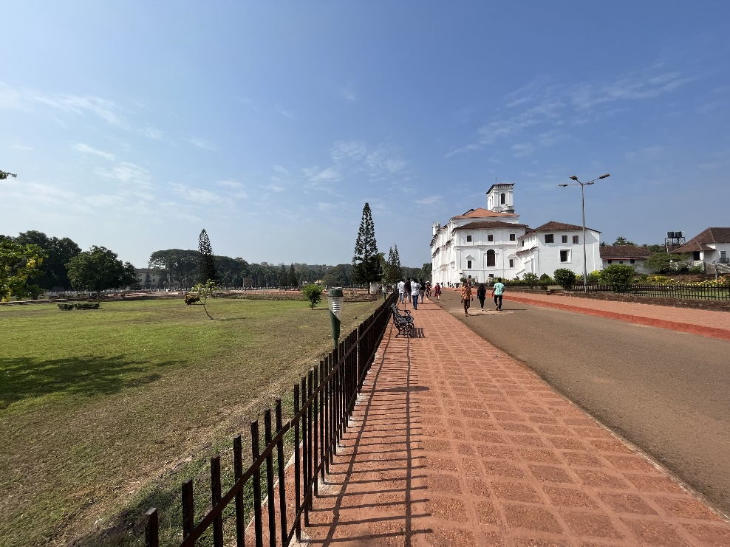

The Basilica of Bom Jesus, located in Old Goa, is a UNESCO World Heritage Site and one of the most iconic landmarks in Goa. Built in the late 16th century, this historic church is renowned for housing the mortal remains of St. Francis Xavier, a revered missionary and patron saint of Goa. The basilica's architecture is a fine example of Baroque style, with its imposing facade adorned with intricate carvings and reliefs depicting scenes from the life of St. Francis Xavier. Inside, visitors can marvel at the ornate interiors, featuring marble flooring, gilded altars, and beautifully crafted statues. The highlight of the basilica is the silver casket containing the relics of St. Francis Xavier, which is displayed to the public every ten years during the Exposition of the Sacred Relics. The Basilica of Bom Jesus is not only a place of pilgrimage for Catholics but also a significant historical and cultural site that attracts visitors from all over the world, offering a glimpse into the rich heritage of Goa and its colonial past.

* Museum of Christian art

The Museum of Christian Art (MoCA) in Old Goa is a unique institution dedicated to preserving and showcasing the rich artistic heritage of Christianity in Goa. Established in 1994, MoCA is housed within the Convent of Santa Monica, a 17th-century building adjacent to the Church of St. Monica. The museum features a diverse collection of religious art and artifacts spanning several centuries, including paintings, sculptures, ivory and silverware, textiles, and liturgical objects. These artifacts offer insight into the fusion of European and Indian artistic traditions that emerged during the colonial period in Goa.

One of the highlights of MoCA is its collection of Portuguese and Indo-Portuguese religious art, which includes intricately carved wooden statues of saints, exquisitely painted altarpieces, and finely crafted religious processional objects. The museum also houses a significant collection of Baroque and Mannerist paintings, showcasing the talent of Goan and European artists of the period.

MoCA provides visitors with a comprehensive understanding of the cultural and religious history of Goa, highlighting the influence of Christianity on the region's artistic expression. Through its exhibitions and educational programs, the museum plays a vital role in promoting appreciation for Goa's Christian heritage and preserving these valuable works of art for future generations.

* Cabo de Rama Fort

Cabo de Rama Fort, situated in South Goa, is a picturesque historical site steeped in legend and offering panoramic views of the Arabian Sea. Believed to have been built by Hindu rulers in ancient times, the fort was later fortified by the Portuguese in the 17th century. It is named after Lord Rama, the protagonist of the Hindu epic Ramayana, who is said to have sought refuge here during his exile.

The fort is characterized by its rugged stone walls and bastions, which enclose a large area atop a cliff overlooking the sea. Within the fort, visitors can explore the remains of various structures, including a small chapel dedicated to St. Anthony and several old cannons. Despite its somewhat dilapidated state, Cabo de Rama Fort exudes an aura of mystery and offers a serene atmosphere ideal for leisurely exploration and enjoying the stunning coastal views.

Apart from its historical significance, the fort is also a popular spot for picnics and photography, attracting both tourists and locals alike. Visitors can reach Cabo de Rama Fort by road, and once there, they can spend time soaking in the scenic beauty, exploring the ruins, and immersing themselves in the rich history and folklore associated with this ancient stronghold.

* BHAGWAN MAHAVIR WILDLIFE CENTURY

Bhagwan Mahavir Wildlife Sanctuary, located in the Sanguem region of Goa, is a haven for nature lovers and wildlife enthusiasts. Spread over an area of approximately 240 square kilometers, this sanctuary is the largest protected area in the state. It is home to a diverse range of flora and fauna, including various species of mammals, birds, reptiles, and amphibians. One of the sanctuary's main attractions is the majestic Dudhsagar Waterfalls, which cascade down from a height of around 600 meters, creating a mesmerizing sight amidst the lush greenery. Visitors can explore the sanctuary through well-marked trekking trails that lead through dense forests and picturesque landscapes. The sanctuary also houses the Tambdi Surla Temple, a small yet ancient temple dedicated to Lord Shiva, adding to the cultural and religious significance of the area. With its rich biodiversity and natural beauty, Bhagwan Mahavir Wildlife Sanctuary offers visitors a tranquil retreat into the heart of Goa's wilderness.

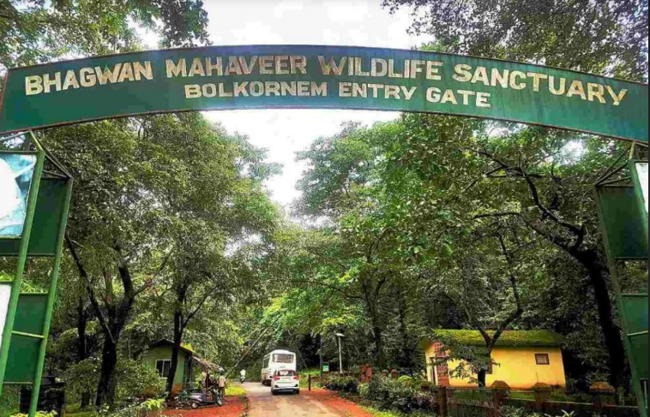

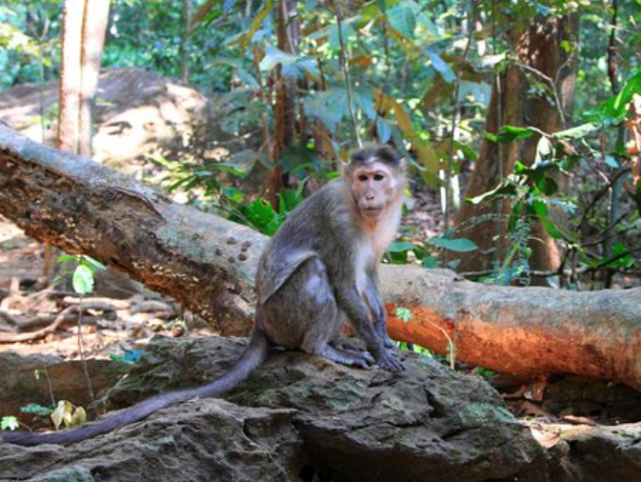RE

* Cabo de Rama Fort

Cabo de Rama Fort, situated in the Canacona region of Goa, holds a rich history and offers a glimpse into the state's colonial past. Perched atop a cliff overlooking the Arabian Sea, this fortress is believed to have been constructed by the Hindu ruler, Rama Kamath, before being captured and renovated by the Portuguese in the 16th century. The fort derives its name from Lord Rama, as legend has it that it was once his refuge during his exile from Ayodhya. Today, the fort stands as a testament to the region's strategic importance during various periods of history. Visitors can explore the remnants of the fort, including the sturdy walls, watchtowers, and cannons, while enjoying panoramic views of the surrounding coastline and the ocean. The tranquil atmosphere and picturesque surroundings make Cabo de Rama Fort a popular destination for tourists seeking a blend of history, culture, and natural beauty during their visit to Goa.

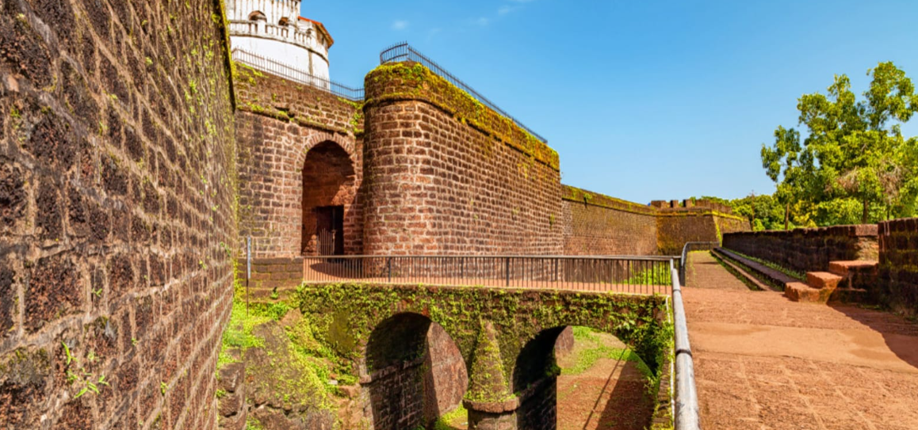

* NAVAL AVIATION MUSEUM

The Naval Aviation Museum in Goa stands as a tribute to the rich history and legacy of Indian naval aviation. Located in the picturesque town of Vasco da Gama, this museum is the only one of its kind in Asia and the second largest naval aviation museum in the world. It showcases a vast collection of aircraft, engines, and other artifacts that highlight the evolution of naval aviation in India. Visitors can marvel at vintage aircraft such as the Sea Harrier, Sea Hawk, and Westland Dragonfly, among others, which are displayed both indoors and outdoors. The museum also features informative exhibits detailing the role of naval aviation in various operations and conflicts throughout history. Interactive displays, simulators, and audio-visual presentations offer visitors a fascinating glimpse into the world of naval aviation. With its extensive collection and engaging exhibits, the Naval Aviation Museum in Goa provides an immersive experience that educates and inspires visitors of all ages.

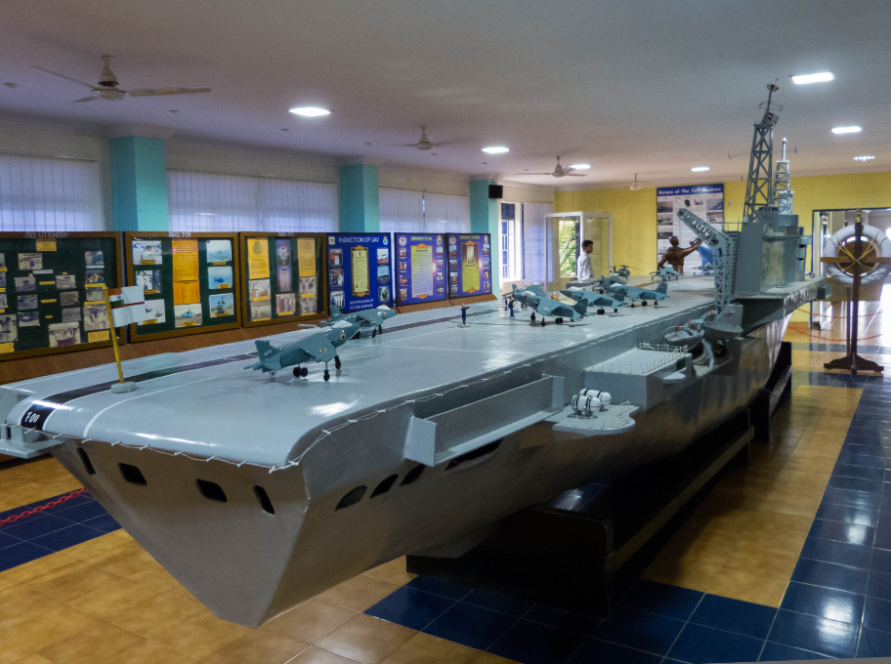

CONCLUSION

REFERENCES